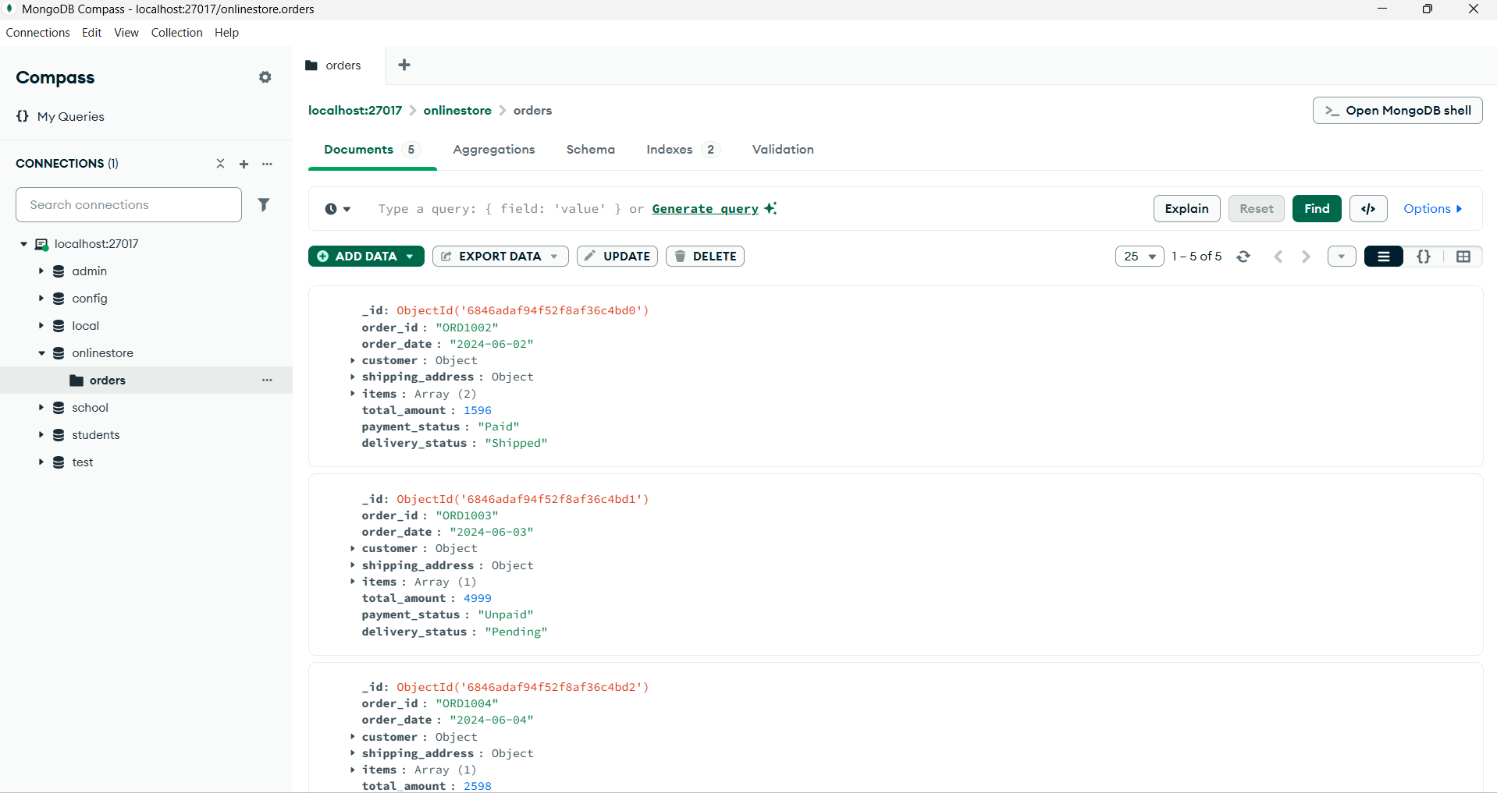**Project 2 – Online Store Management System Using MongoDB**

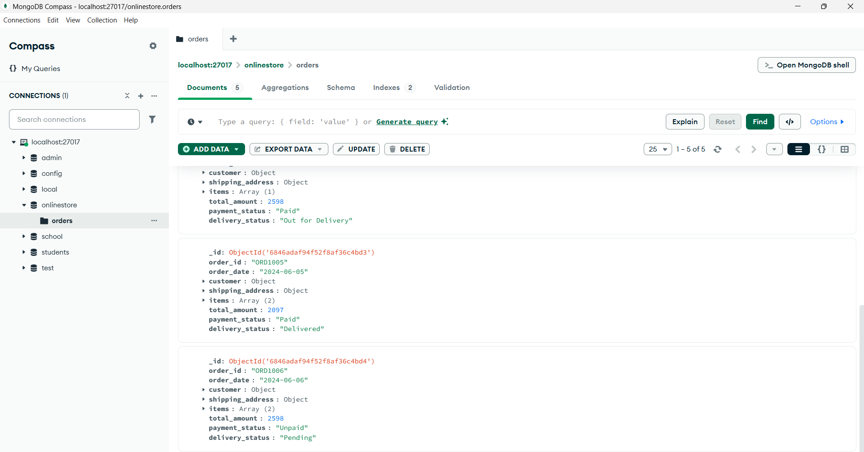

Microsoft Windows [Version 10.0.26100.4061]

(c) Microsoft Corporation. All rights reserved.

C:\Users\Sakshi Rathi>mongosh

test> **use onlinestore**

switched to db onlinestore

onlinestore> db.createCollection("orders")

{ ok: 1 }

**Q1. Insert 5 different orders**

onlinestore> db.orders.insertMany([

... {

... "order_id": "ORD1002",

... "order_date": "2024-06-02",

... "customer": {

... "name": "Raj Mehta",

... "email": "raj@example.com",

... "phone": "9876500001"

... },

... "shipping_address": {

... "street": "456 Hill View",

... "city": "Delhi",

... "state": "DL",

... "pincode": "110001"

... },

... "items": [

... { "product": "Laptop Bag", "price": 1299, "quantity": 1 },

... { "product": "Notebook", "price": 99, "quantity": 3 }

... ],

... "total_amount": 1596,

... "payment_status": "Paid",

... "delivery_status": "Shipped"

... },

... {

... "order_id": "ORD1003",

... "order_date": "2024-06-03",

... "customer": {

... "name": "Anjali Verma",

... "email": "anjali@example.com",

... "phone": "9876500002"

... },

... "shipping_address": {

... "street": "789 Rose Villa",

... "city": "Bangalore",

... "state": "KA",

... "pincode": "560001"

... },

... "items": [

... { "product": "Monitor", "price": 4999, "quantity": 1 }

... ],

... "total_amount": 4999,

... "payment_status": "Unpaid",

... "delivery_status": "Pending"

... },

... {

... "order_id": "ORD1004",

... "order_date": "2024-06-04",

... "customer": {

... "name": "Farhan Ali",

... "email": "farhan@example.com",

... "phone": "9876500003"

... },

... "shipping_address": {

... "street": "22 Sky Tower",

... "city": "Hyderabad",

... "state": "TS",

... "pincode": "500001"

... },

... "items": [

... { "product": "Power Bank", "price": 1299, "quantity": 2 }

... ],

... "total_amount": 2598,

... "payment_status": "Paid",

... "delivery_status": "Out for Delivery"

... },

... {

... "order_id": "ORD1005",

... "order_date": "2024-06-05",

... "customer": {

... "name": "Nina Das",

... "email": "nina@example.com",

... "phone": "9876500004"

... },

... "shipping_address": {

... "street": "500 River Side",

... "city": "Chennai",

... "state": "TN",

... "pincode": "600001"

... },

... "items": [

... { "product": "USB Hub", "price": 799, "quantity": 2 },

... { "product": "HDMI Cable", "price": 499, "quantity": 1 }

... ],

... "total_amount": 2097,

... "payment_status": "Paid",

... "delivery_status": "Delivered"

... },

... {

... "order_id": "ORD1006",

... "order_date": "2024-06-06",

... "customer": {

... "name": "Arjun Sen",

... "email": "arjun@example.com",

... "phone": "9876500005"

... },

... "shipping_address": {

... "street": "88 Market Road",

... "city": "Kolkata",

... "state": "WB",

... "pincode": "700001"

... },

... "items": [

... { "product": "Webcam", "price": 1599, "quantity": 1 },

... { "product": "Tripod", "price": 999, "quantity": 1 }

... ],

... "total_amount": 2598,

... "payment_status": "Unpaid",

... "delivery_status": "Pending"

... }

... ])

...

{

acknowledged: true,

insertedIds: {

'0': ObjectId('6846adaf94f52f8af36c4bd0'),

'1': ObjectId('6846adaf94f52f8af36c4bd1'),

'2': ObjectId('6846adaf94f52f8af36c4bd2'),

'3': ObjectId('6846adaf94f52f8af36c4bd3'),

'4': ObjectId('6846adaf94f52f8af36c4bd4')

}

}

**Q2. Find all orders where payment_status is "Paid" but delivery_status is not "Delivered"**

onlinestore> db.orders.find({

... payment_status: "Paid",

... delivery_status: { $ne: "Delivered" }

... })

[

{

_id: ObjectId('6846adaf94f52f8af36c4bd0'),

order_id: 'ORD1002',

order_date: '2024-06-02',

customer: {

name: 'Raj Mehta',

email: 'raj@example.com',

phone: '9876500001'

},

shipping_address: {

street: '456 Hill View',

city: 'Delhi',

state: 'DL',

pincode: '110001'

},

items: [

{ product: 'Laptop Bag', price: 1299, quantity: 1 },

{ product: 'Notebook', price: 99, quantity: 3 }

],

total_amount: 1596,

payment_status: 'Paid',

delivery_status: 'Shipped'

},

{

_id: ObjectId('6846adaf94f52f8af36c4bd2'),

order_id: 'ORD1004',

order_date: '2024-06-04',

customer: {

name: 'Farhan Ali',

email: 'farhan@example.com',

phone: '9876500003'

},

shipping_address: {

street: '22 Sky Tower',

city: 'Hyderabad',

state: 'TS',

pincode: '500001'

},

items: [ { product: 'Power Bank', price: 1299, quantity: 2 } ],

total_amount: 2598,

payment_status: 'Paid',

delivery_status: 'Out for Delivery'

} ]

**Q3. List all orders that contain at least one product priced more than 1000**

onlinestore> db.orders.find({

... "items.price": { $gt: 1000 }

... })

...

[

{

_id: ObjectId('6846adaf94f52f8af36c4bd0'),

order_id: 'ORD1002',

order_date: '2024-06-02',

customer: {

name: 'Raj Mehta',

email: 'raj@example.com',

phone: '9876500001'

},

shipping_address: {

street: '456 Hill View',

city: 'Delhi',

state: 'DL',

pincode: '110001'

},

items: [

{ product: 'Laptop Bag', price: 1299, quantity: 1 },

{ product: 'Notebook', price: 99, quantity: 3 }

],

total_amount: 1596,

payment_status: 'Paid',

delivery_status: 'Shipped'

},

{

_id: ObjectId('6846adaf94f52f8af36c4bd1'),

order_id: 'ORD1003',

order_date: '2024-06-03',

customer: {

name: 'Anjali Verma',

email: 'anjali@example.com',

phone: '9876500002'

},

shipping_address: {

street: '789 Rose Villa',

city: 'Bangalore',

state: 'KA',

pincode: '560001'

},

items: [ { product: 'Monitor', price: 4999, quantity: 1 } ],

total_amount: 4999,

payment_status: 'Unpaid',

delivery_status: 'Pending'

},

{

_id: ObjectId('6846adaf94f52f8af36c4bd2'),

order_id: 'ORD1004',

order_date: '2024-06-04',

customer: {

name: 'Farhan Ali',

email: 'farhan@example.com',

phone: '9876500003'

},

shipping_address: {

street: '22 Sky Tower',

city: 'Hyderabad',

state: 'TS',

pincode: '500001'

},

items: [ { product: 'Power Bank', price: 1299, quantity: 2 } ],

total_amount: 2598,

payment_status: 'Paid',

delivery_status: 'Out for Delivery'

},

{

_id: ObjectId('6846adaf94f52f8af36c4bd4'),

order_id: 'ORD1006',

order_date: '2024-06-06',

customer: {

name: 'Arjun Sen',

email: 'arjun@example.com',

phone: '9876500005'

},

shipping_address: {

street: '88 Market Road',

city: 'Kolkata',

state: 'WB',

pincode: '700001'

},

items: [

{ product: 'Webcam', price: 1599, quantity: 1 },

{ product: 'Tripod', price: 999, quantity: 1 }

],

total_amount: 2598,

payment_status: 'Unpaid',

delivery_status: 'Pending' }]

**Q4. Get a list of orders shipped to “Mumbai” or “Delhi” sorted by most recent date**

onlinestore> db.orders.find(

... { "shipping_address.city": { $in: ["Mumbai", "Delhi"] } },

... { order_id: 1, "shipping_address.city": 1, order_date: 1, _id: 0 }

... ).sort({ order_date: -1 })

...

[

{

order_id: 'ORD1002',

order_date: '2024-06-02',

shipping_address: { city: 'Delhi' }

}

]

**Q5. Group orders by payment_status and count how many orders fall under each category**

onlinestore> db.orders.aggregate([

... { $group: { _id: "$payment_status", total_orders: { $sum: 1 } } }

... ])

...

[

{ _id: 'Paid', total_orders: 3 },

{ _id: 'Unpaid', total_orders: 2 }

]

**Q6. Calculate the total revenue (sum of total_amount) from all "Delivered" orders**

onlinestore> db.orders.aggregate([

... { $match: { delivery_status: "Delivered" } },

... { $group: { _id: null, total_revenue: { $sum: "$total_amount" } } }

... ])

...

[ { _id: null, total_revenue: 2097 } ]

**Q7. Add a new field "priority": "High" to all orders that have more than 3 items**

onlinestore> db.orders.updateMany(

... { $expr: { $gt: [ { $size: "$items" }, 3 ] } },

... { $set: { priority: "High" } }

... )

...

{

acknowledged: true,

insertedId: null,

matchedCount: 0,

modifiedCount: 0,

upsertedCount: 0

}

**Q8. Count how many times each product was ordered (regardless of order)**

onlinestore> db.orders.aggregate([

... { $unwind: "$items" },

... { $group: {

... _id: "$items.product",

... total_quantity: { $sum: "$items.quantity" }

... }}

... ])

...

[

{ _id: 'Webcam', total_quantity: 1 },

{ _id: 'USB Hub', total_quantity: 2 },

{ _id: 'Laptop Bag', total_quantity: 1 },

{ _id: 'Tripod', total_quantity: 1 },

{ _id: 'HDMI Cable', total_quantity: 1 },

{ _id: 'Monitor', total_quantity: 1 },

{ _id: 'Notebook', total_quantity: 3 },

{ _id: 'Power Bank', total_quantity: 2 }

]

**Q9. Add a new item to an existing order (e.g., add "USB Cable" to order_id ORD1001)**

onlinestore> db.orders.updateOne(

... { order_id: "ORD1001" },

... { $push: {

... items: { product: "USB Cable", price: 299, quantity: 1 }

... }}

... )

...

{

acknowledged: true,

insertedId: null,

matchedCount: 0,

modifiedCount: 0,

upsertedCount: 0

}

**Q10. Rename field "phone" inside customer object to "mobile_number" across all documents**

onlinestore> db.orders.updateMany(

... {},

... { $rename: { "customer.phone": "customer.mobile_number" } }

... )

...

{

acknowledged: true,

insertedId: null,

matchedCount: 5,

modifiedCount: 5,

upsertedCount: 0 }

**Q11. Create an index on the customer email to speed up lookups.**

onlinestore> db.orders.createIndex({ "customer.email": 1 })

customer.email_1

**Q12. Export the data using `mongoexport` for reporting purposes.**

onlinestore> mongoexport --db onlinestore --collection orders --out orders_export.json

… 2025-06-09T15:37:12.345+0530 connected to: mongodb://localhost:27017/

…2025-06-09T15:37:12.678+0530 exported 5 records

onlinestore>